**Git and GitHub Assignment**

**GIT BRANCHING**

**Section 1 : (HTML Assignments)**

21. First take a backup of your assignments & projects. This is required because due to

incorrect GIT operation you may lose your files.

**I have backed up the previous section “project_dir” in “Git Branching/” directory and also added some sample .html, .css and .js files in that folder.**

22. Create an empty directory 'Assignments' & cd to “Assignments'. 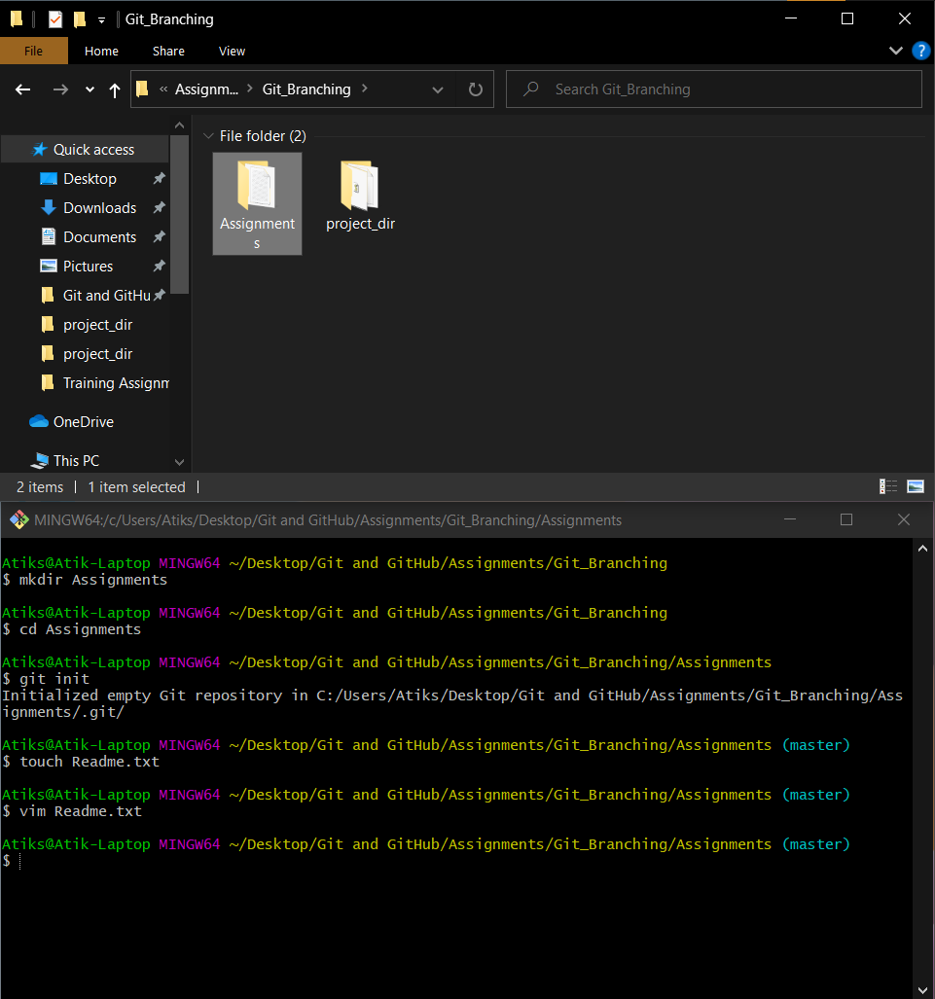

23. Create a file README.txt inside 'Assignments' & write few lines about the contents of 'Assignments' folder.



**Edited The Readme.txt file**

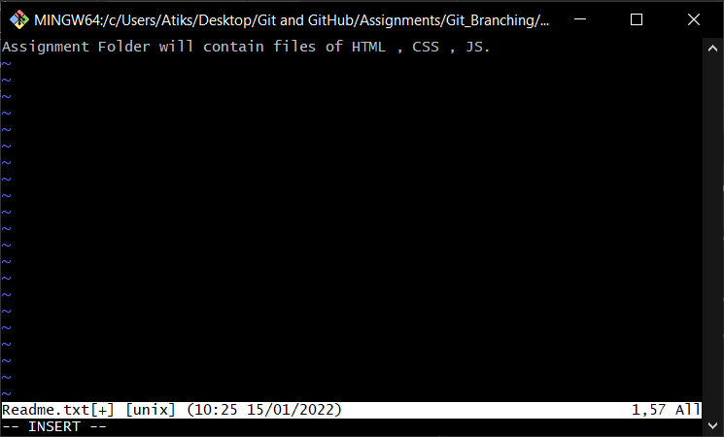

24. Commit README.txt file.

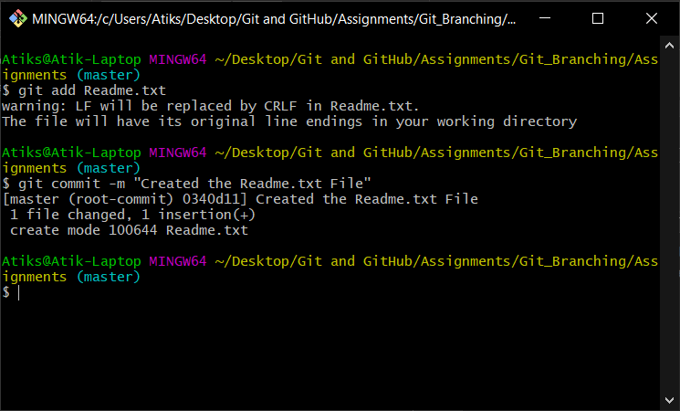

25. Now create a new branch 'html-assignments'.

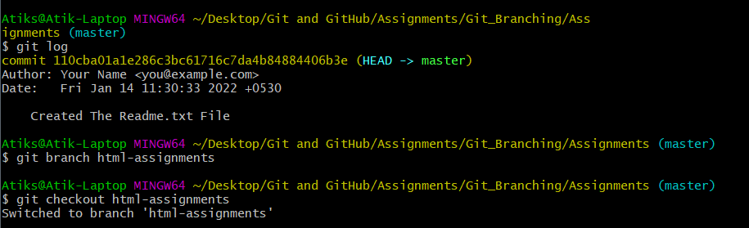

26. Switch to 'html-assignments' branch.



27. Copy all HTML assignments inside 'Assignments' folder.

**I have copied the index.html file in “Assignments” folder from “project_dir “ folder**

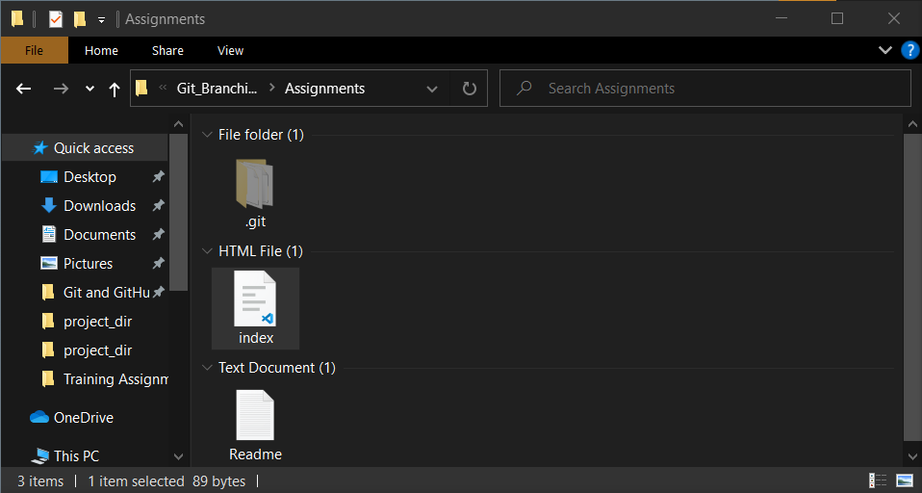

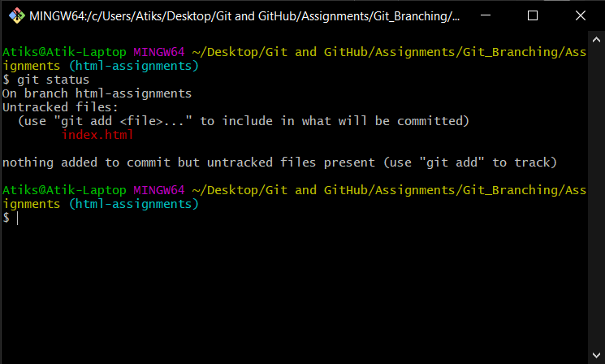

28. Commit HTML assignments into 'html-assignments' branch.

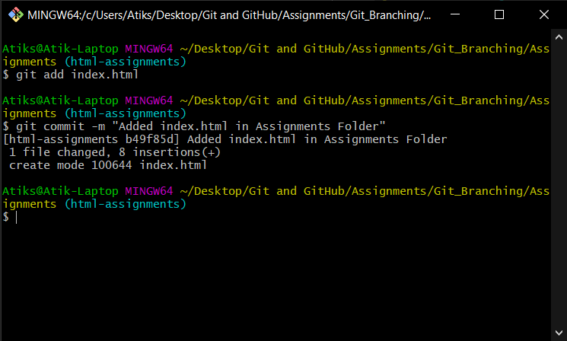

29. Make minor changes into few files belonging to 'html-assignments' branch.



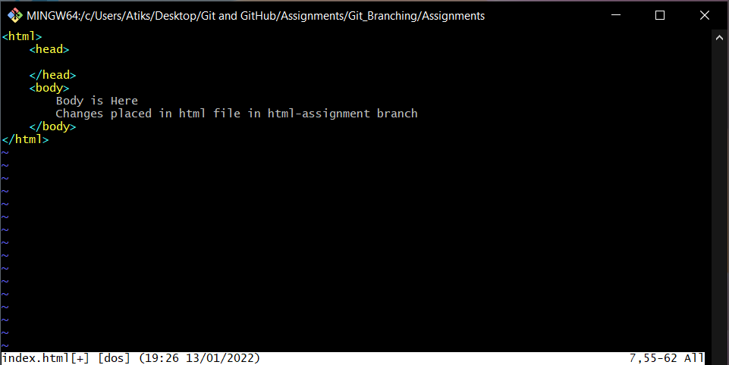

30. Commit those changed files.

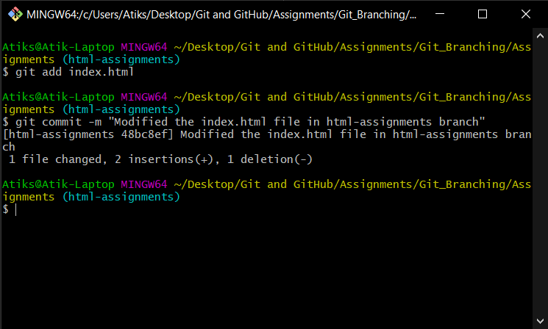

31. Switch to master branch.

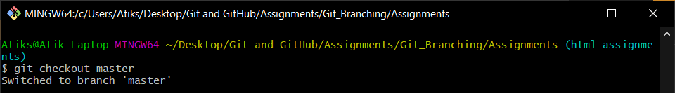

32. Make minor changes into README.txt file & commit those changes into master.

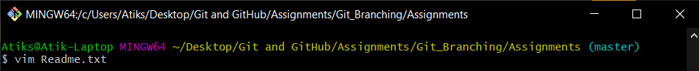

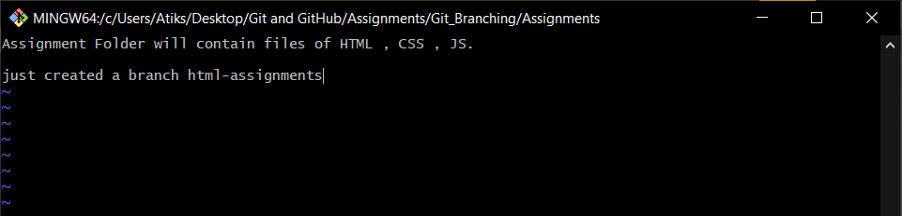

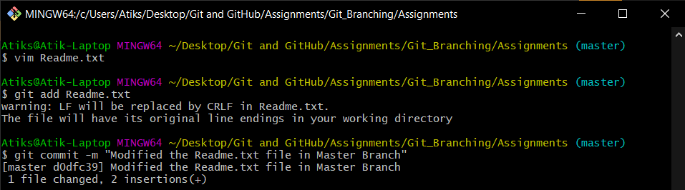

33. Again switch to 'html-assignments' branch.

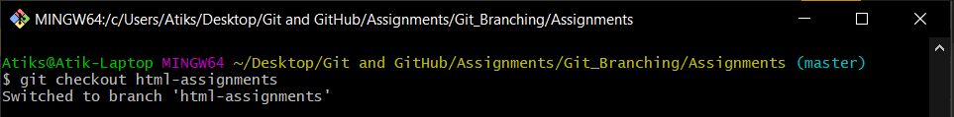

34. Make minor changes into few files belonging to 'html-assignments' branch.

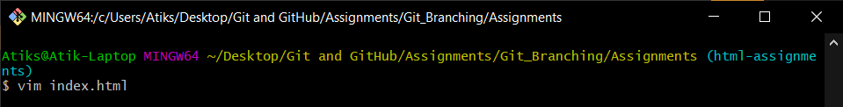

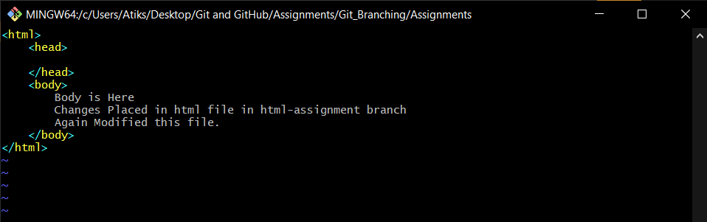

35. Commit those changes.

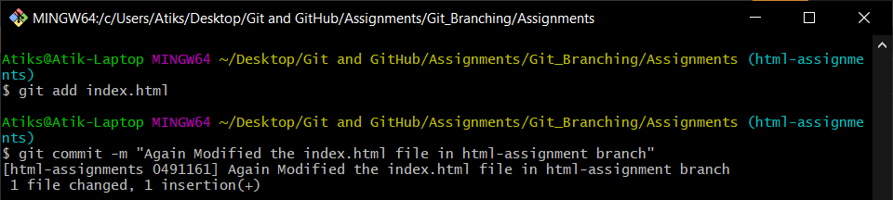

36. Switch to master

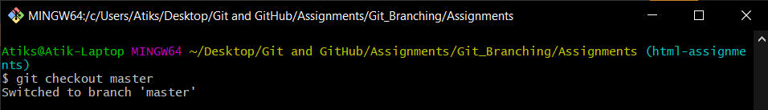

37. Merge 'html-assignments' branch into master. Confirm all html assignments are shown

in master.

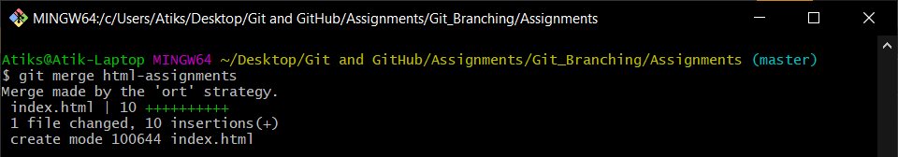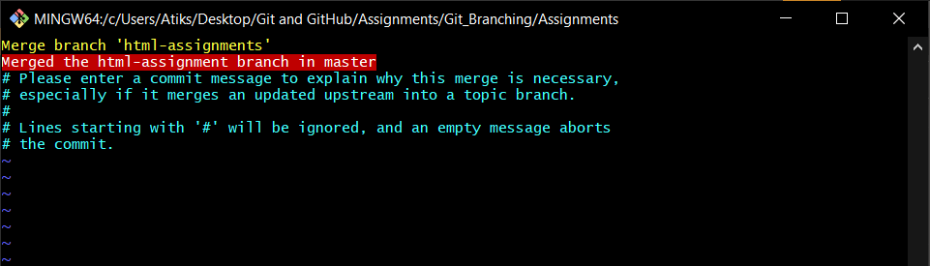

38. Finally delete the 'html-assignments' branch.

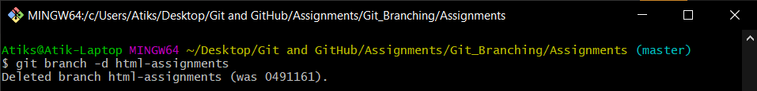

**Git log before deleting html-assignment branch**

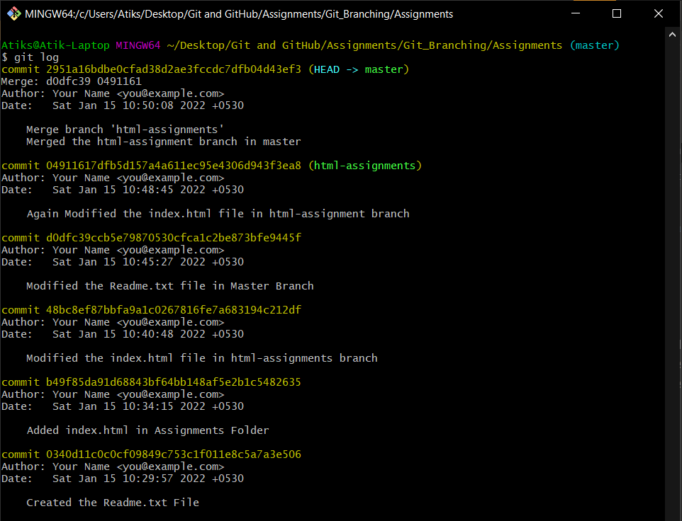

**Git log after deleting html-assignment branch**

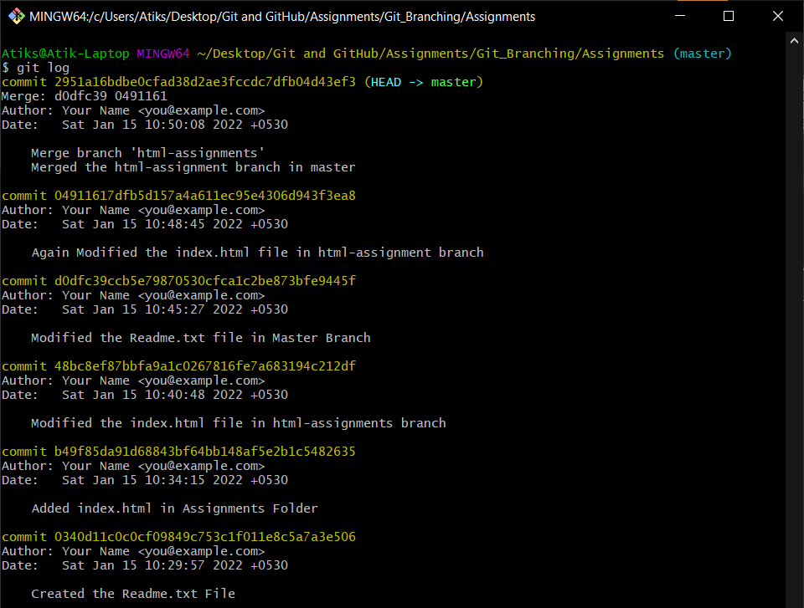

**Section 2 : (CSS Assignments)**

1. Create a new branch 'css-assignments'.

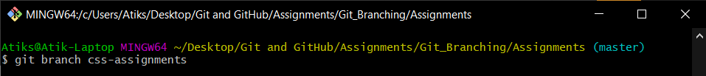

2. Switch to 'css-assignments' branch.

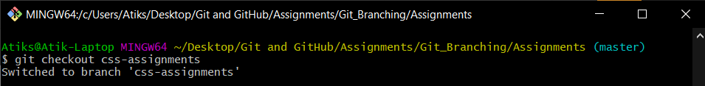

3. Copy all CSS assignments inside 'Assignments' folder.

**Copied an empty .css file in assignments folder**

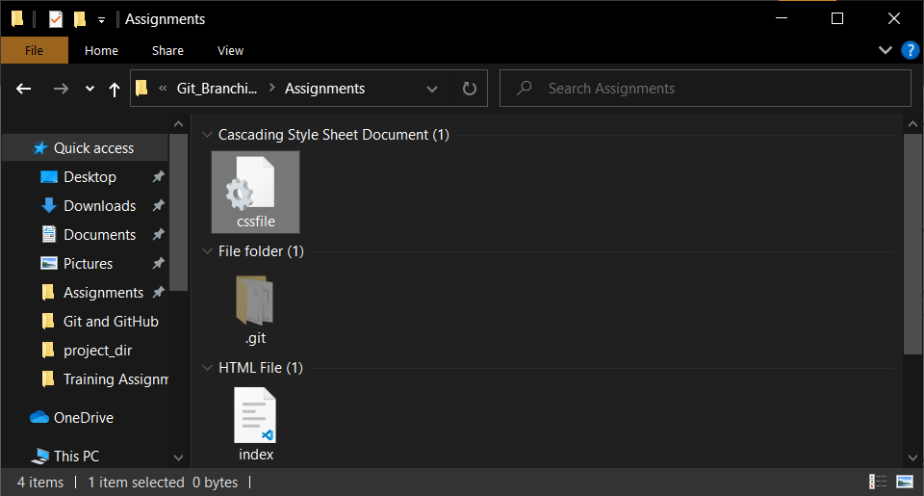

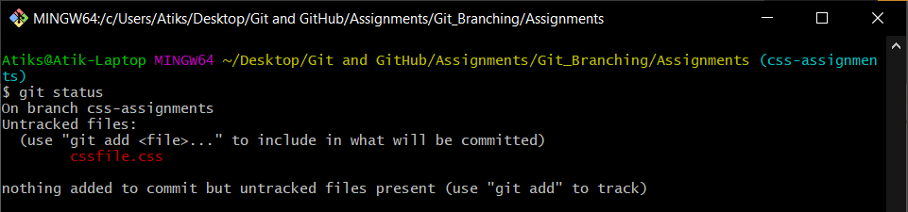

4. Commit CSS assignments into 'css-assignments' branch.

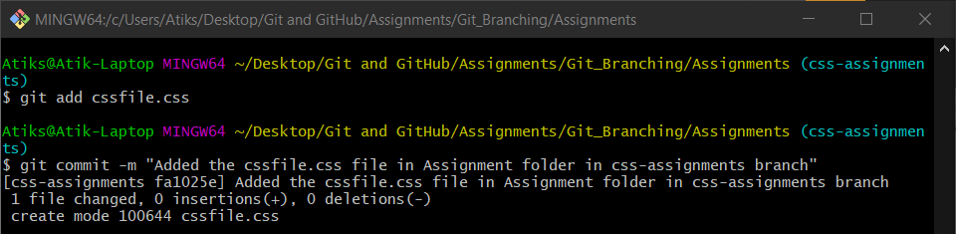

5. Make minor changes into README.txt file on line 1 belonging to 'css-assignments'

branch.

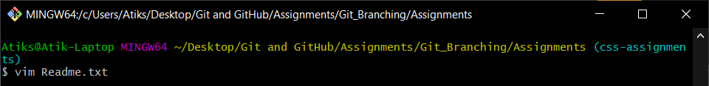

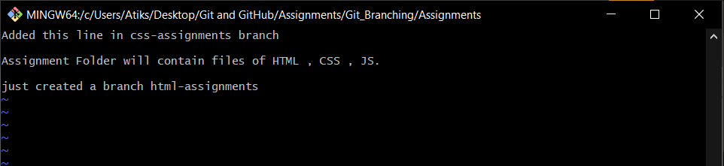

6. Commit those changed files.

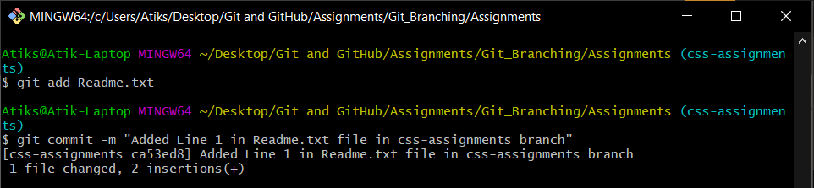

7. Switch to master branch.

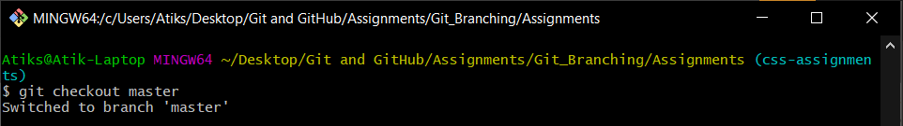

8. Make minor changes into README.txt file on line 3 & commit those changes into

master.

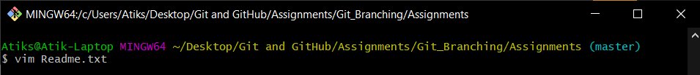

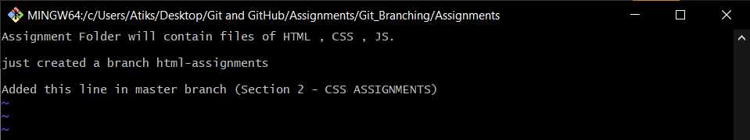

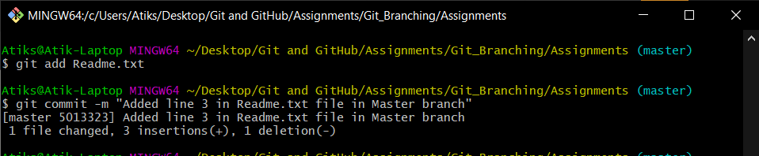

9. Again switch to 'css-assignments branch.

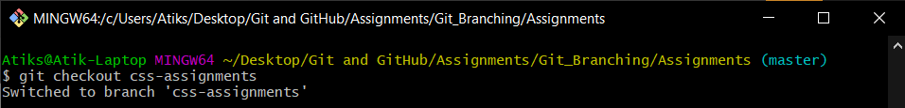

10. Make minor changes into few files belonging to 'css-assignments' branch.

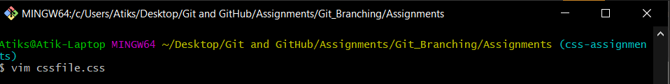

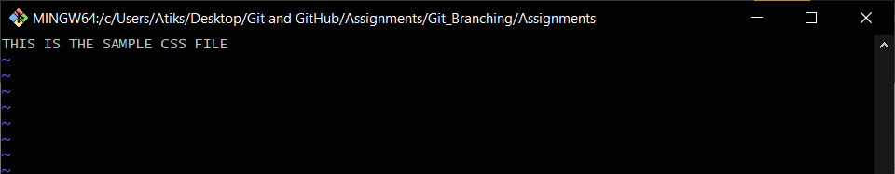

11. Commit those changes.

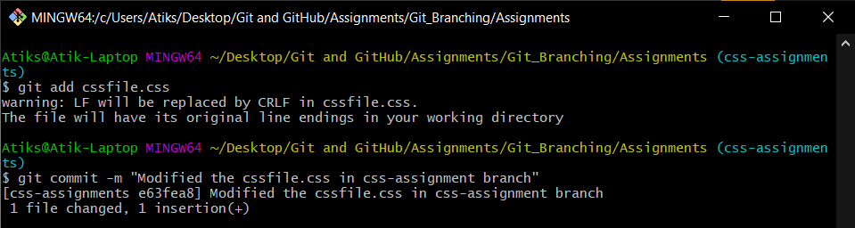

12. Switch to master.

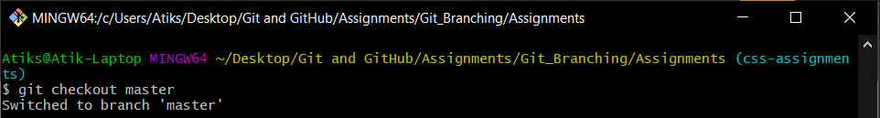

13. Merge css-assignments' branch into master. Confirm all css assignments are shown in

master.

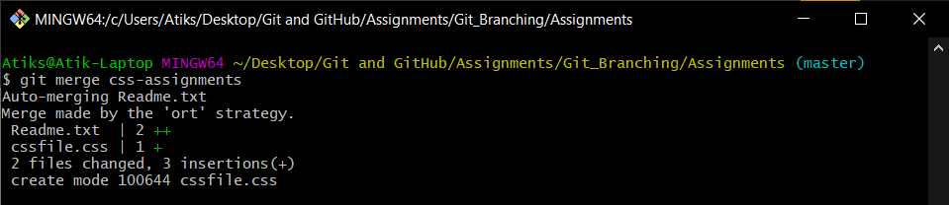

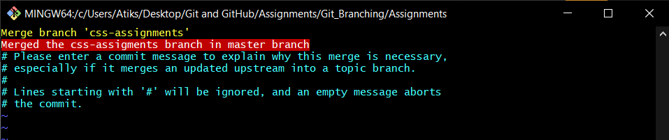

14. Finally delete the 'css-assignments' branch.

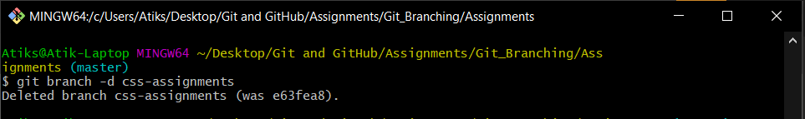

**Git log before deleting the css-assignments branch**

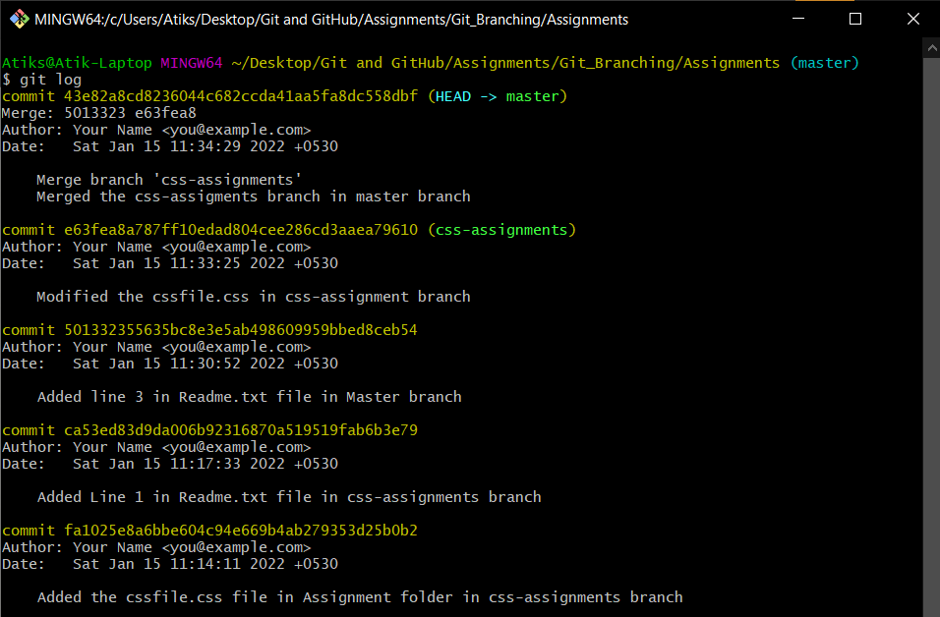

**Git log after deleting the css-assignments branch**

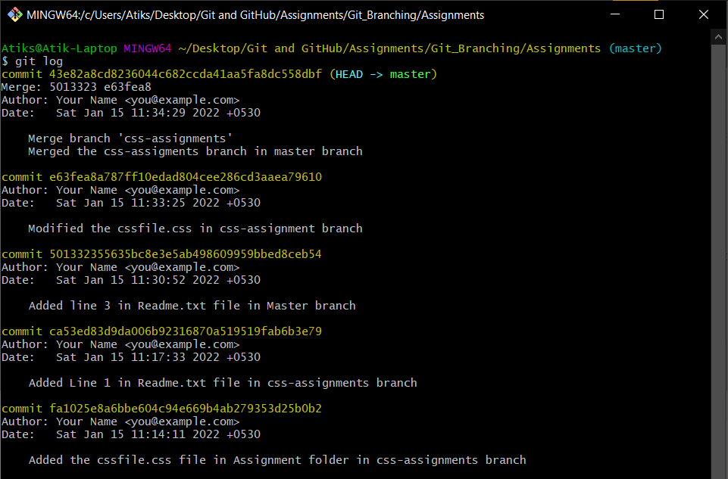

**Section 3 : (JS Assignments)**

1. Create a new branch 'js-assignments'.

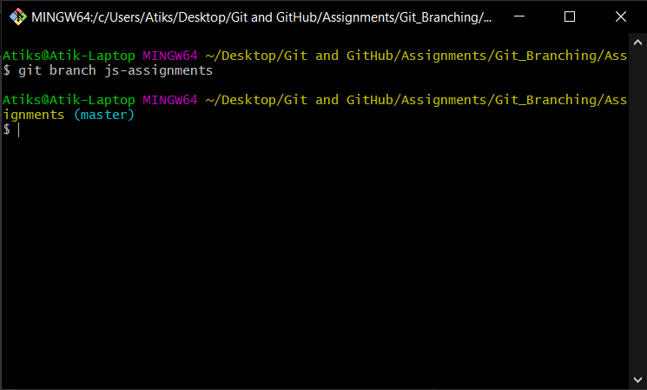

2. Switch to 'js-assignments' branch.

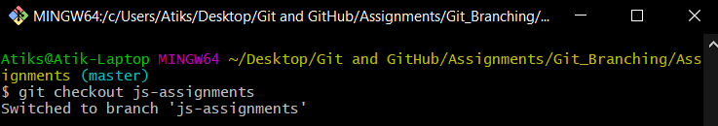

3. Copy all JavaScript assignments inside 'Assignments' folder.

**Copied a empty .js file in Assignment folder** 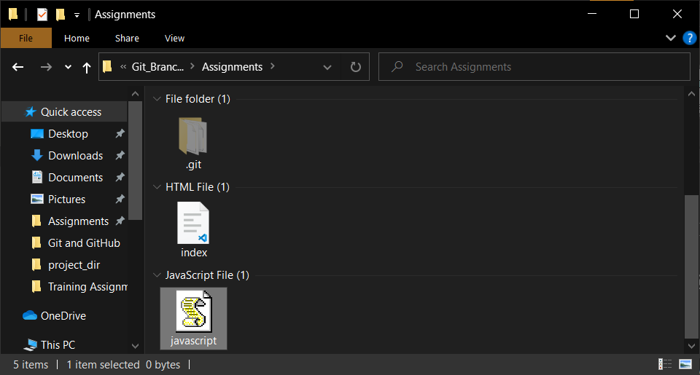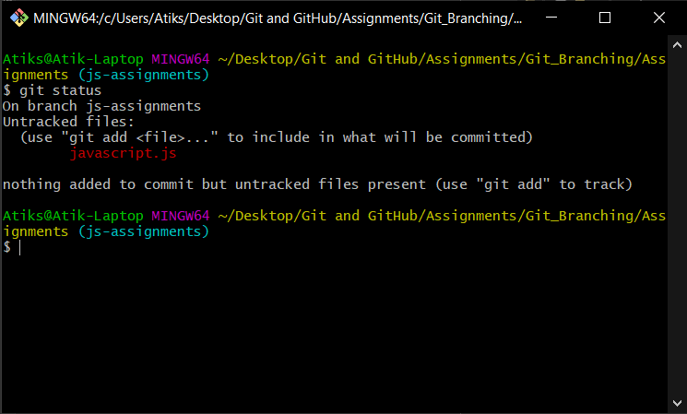

4. Commit JavaScript assignments into 'js-assignments' branch.

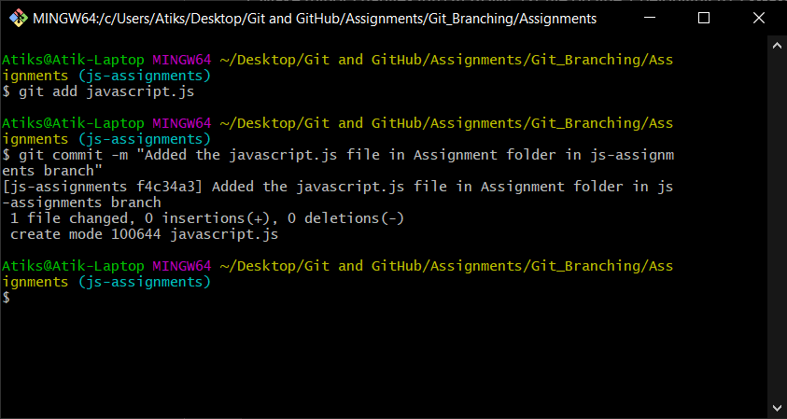

5. Make minor changes into README.txt file on line 1 belonging to 'js-assignments' branch.

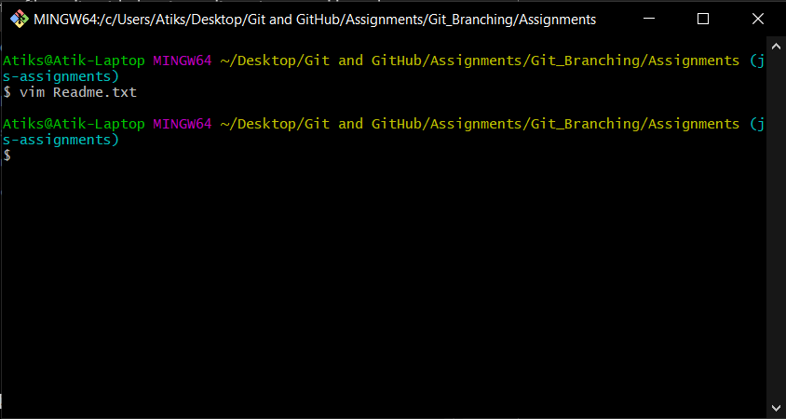

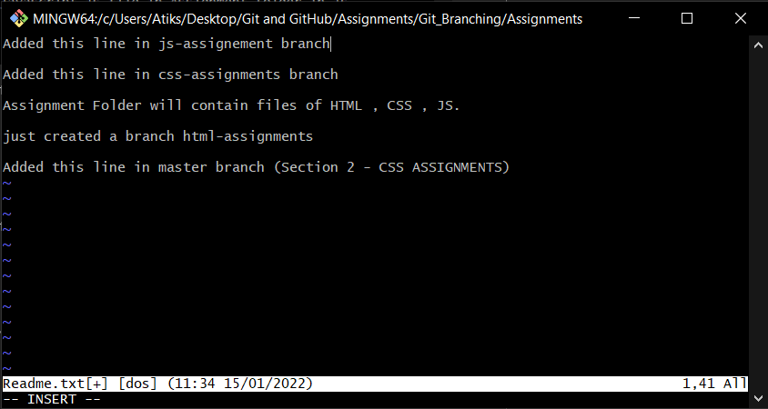

6. Commit those changed files.

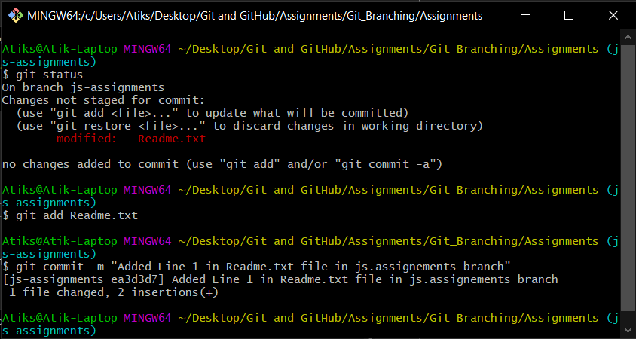

7. Switch to master branch.

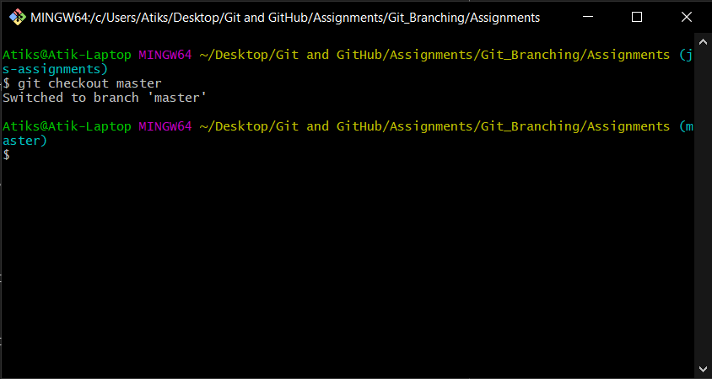

8. Make minor changes into README.txt file on line 1 & commit those changes into

master.

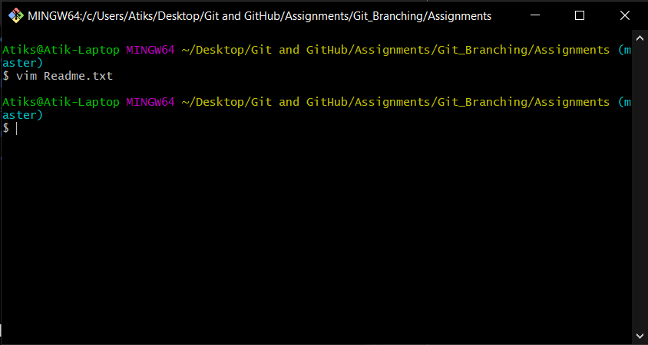

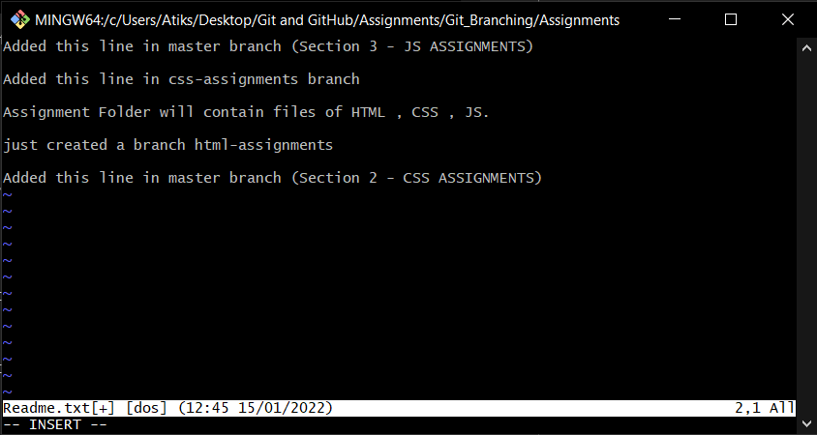

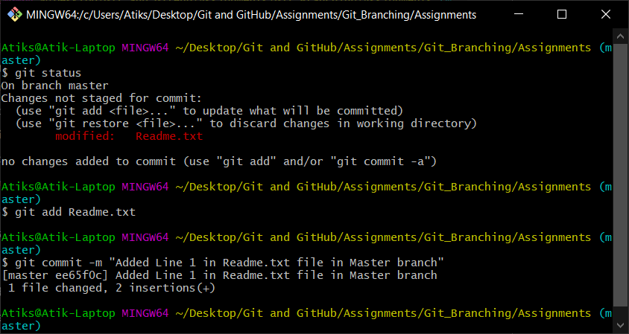

9. Again switch to 'js-assignments' branch.

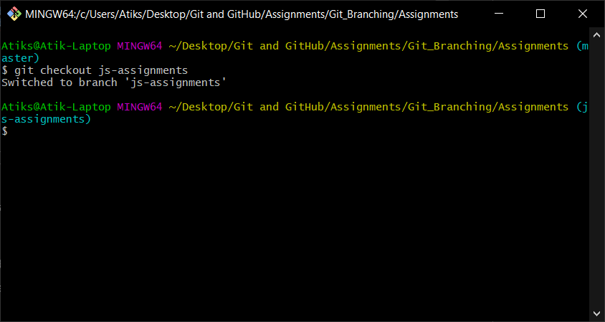

10. Make minor changes into few files belonging to 'js-assignments' branch.

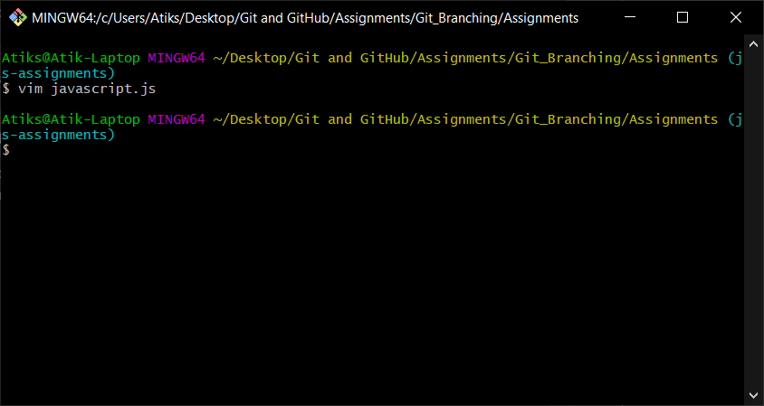

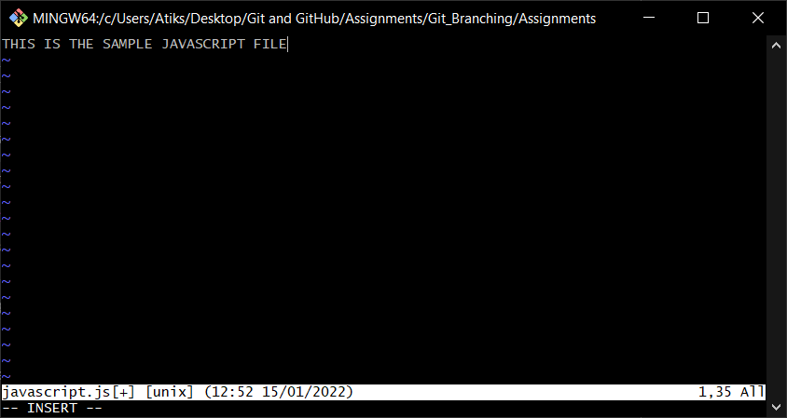

11. Commit those changes.

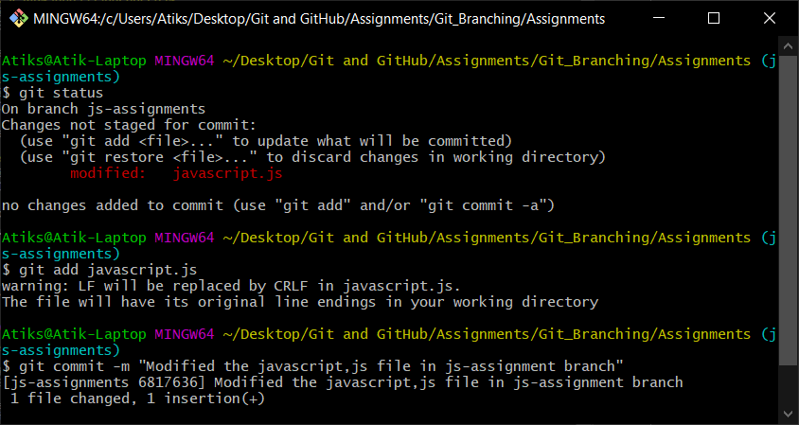

12. Switch to master.

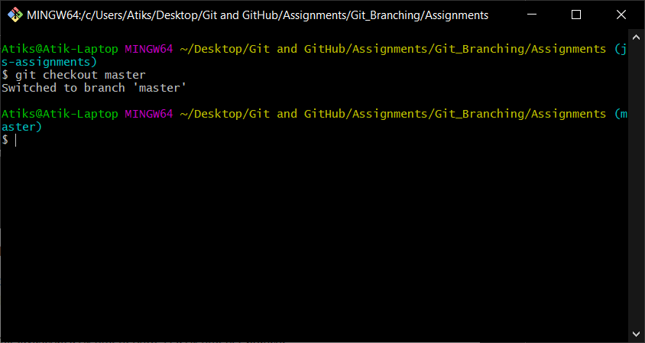

13. Merge 'js-assignments' branch into master. Confirm all JavaScript assignments are

shown in master.

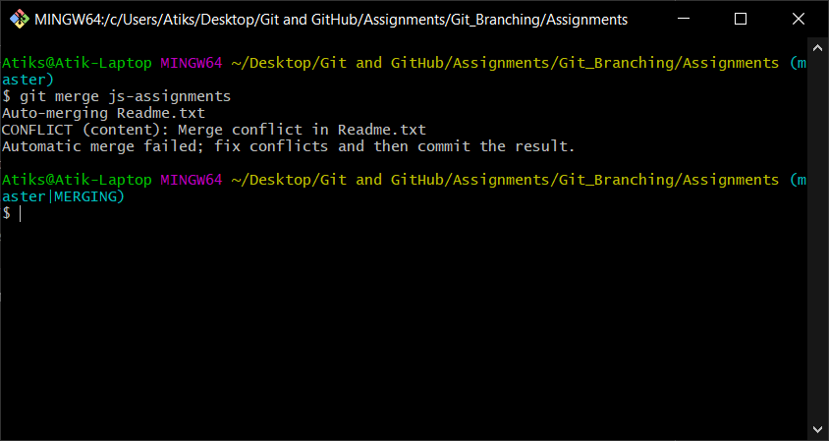

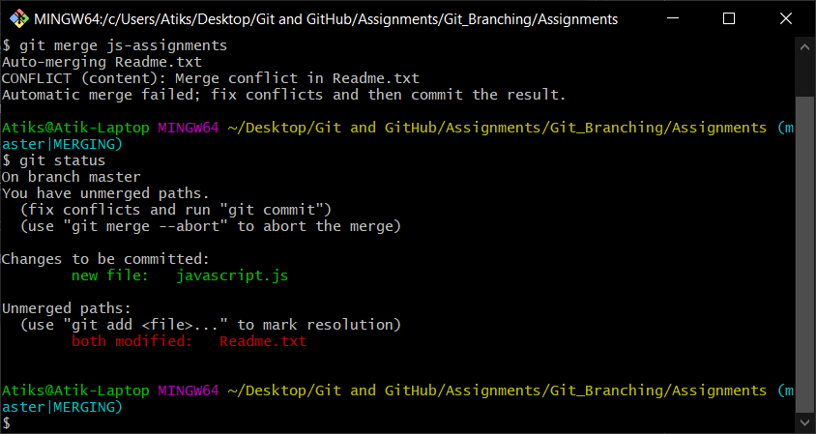

**Here we have a conflict in merging Readme.txt in master from js-assignment branch.**

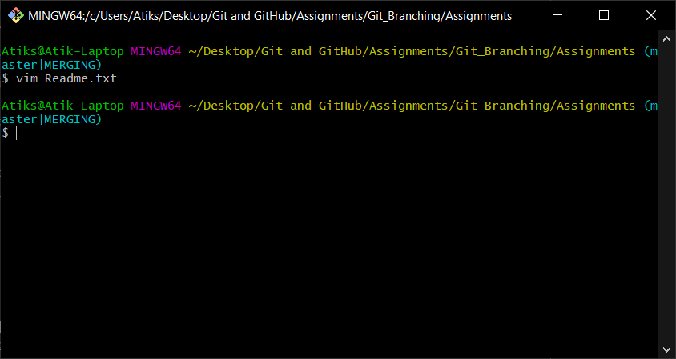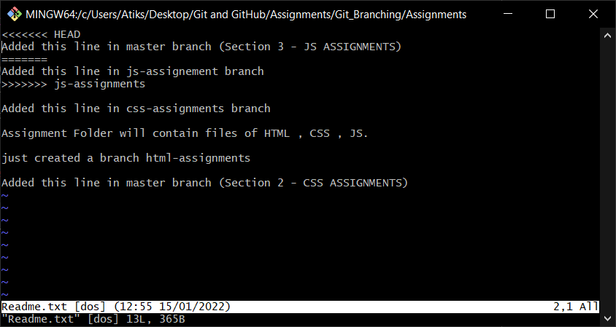

**Manually merged the Readme.txt file**

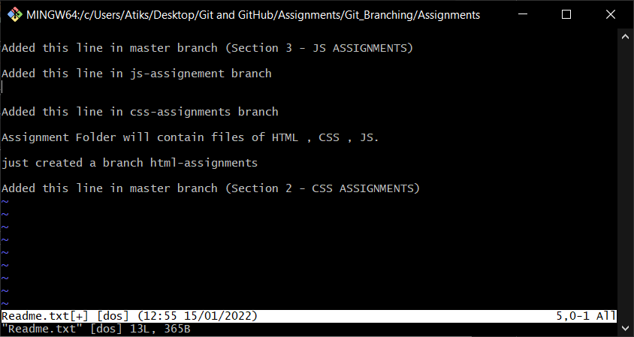

**Again staged the Readme.txt file**

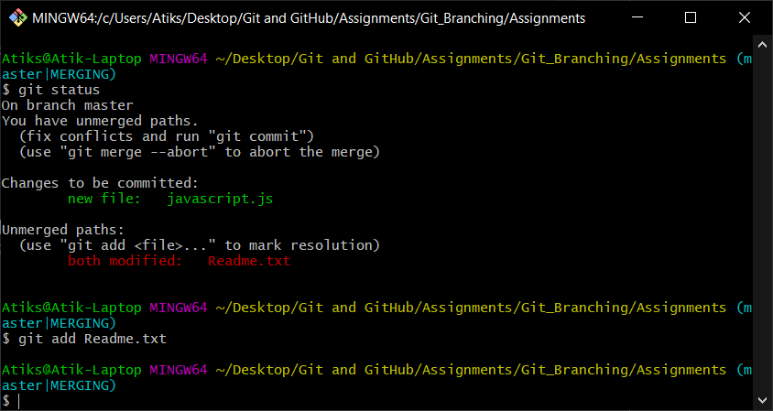

**Committed the staged files**

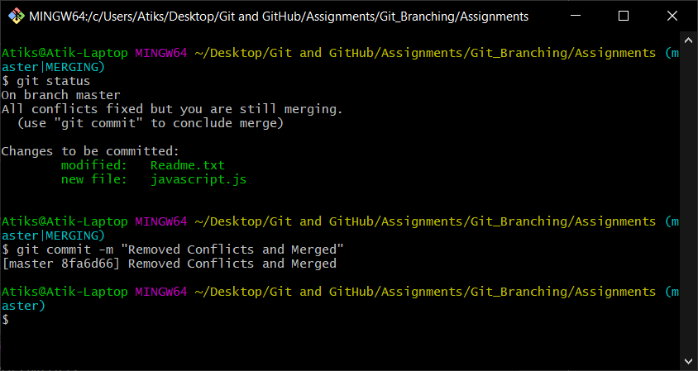

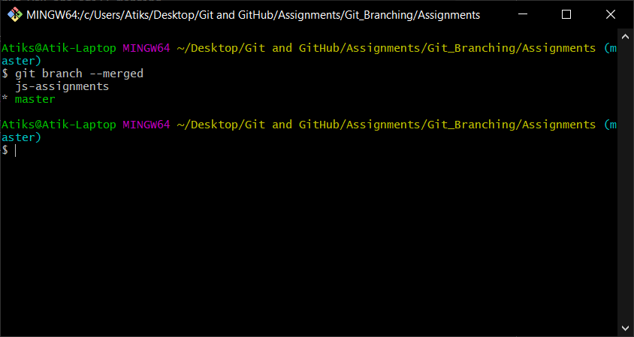

14. Finally delete the 'js-assignments branch.

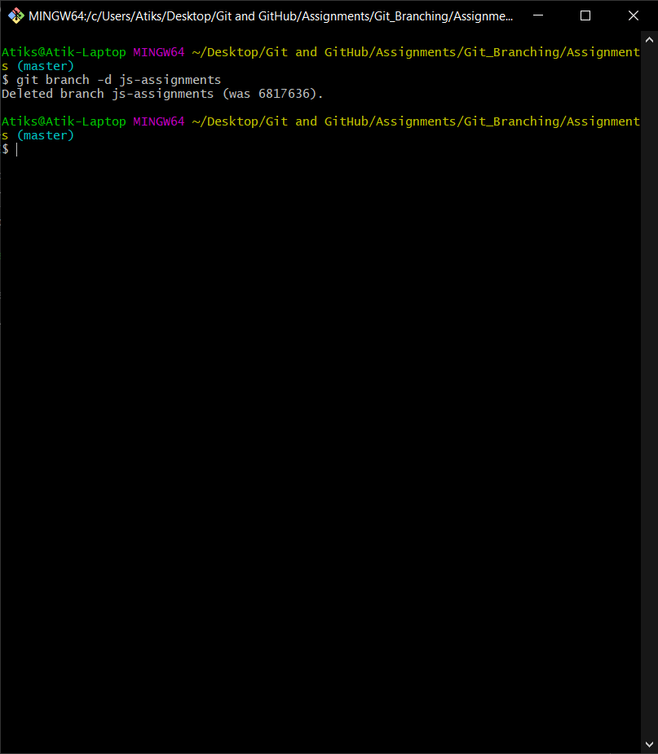

**Git log before removing js-assignment branch**

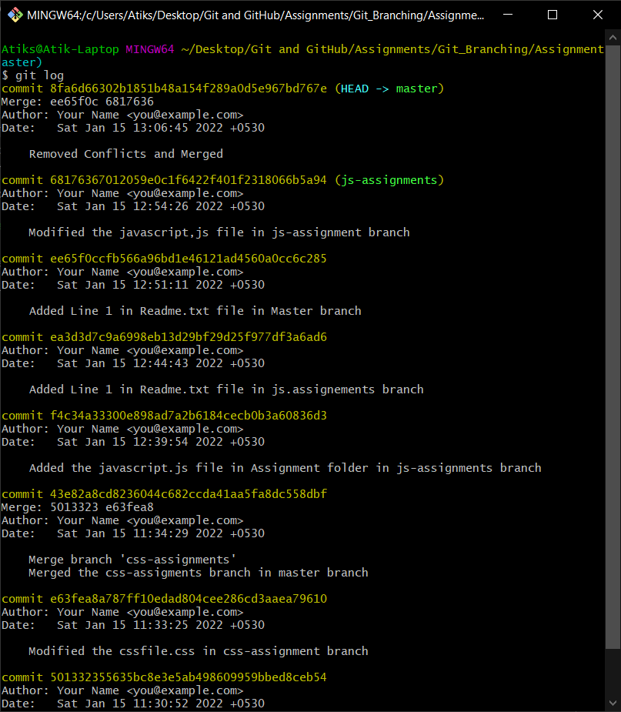

**Git log after removing js-assignment branch**